Parallel Programming Basics:

Make: dd_serial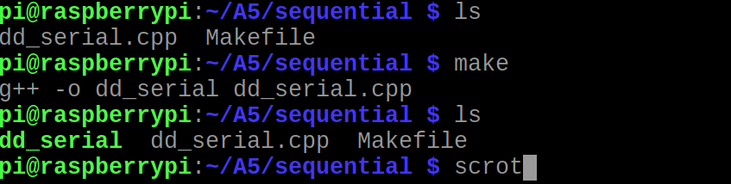

I was able to move the files and create the exacutable without issues.

Make: dd_omp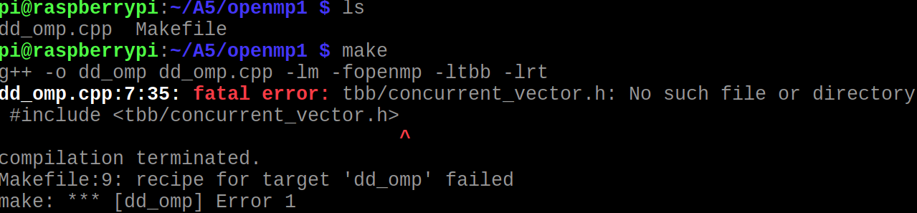

When trying to create the dd_omp.exe, I ran into this error. The error was solved by installing the TBB Librabies.

Get and unpack the libraries.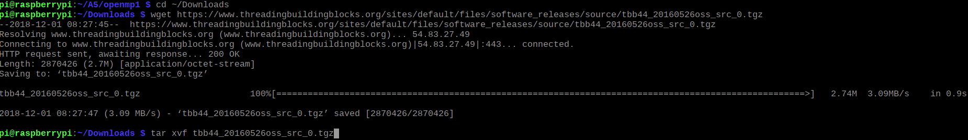

I followed the instruction on how to install from online. Mostly pasting provided commands into the terminal.

After installing TBB I ran into a new error.

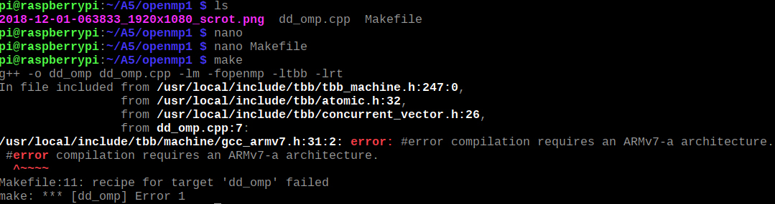

After resurching, I discovered I needed to add new flags to the Makefile.

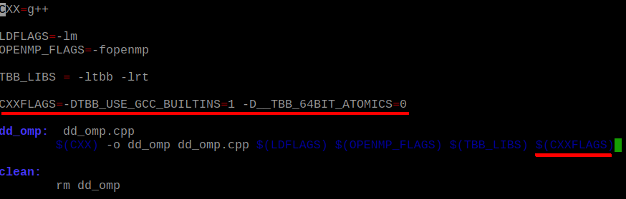

After adding these flags the code compiled.



I got the same error for the dd_therads with the same fix.

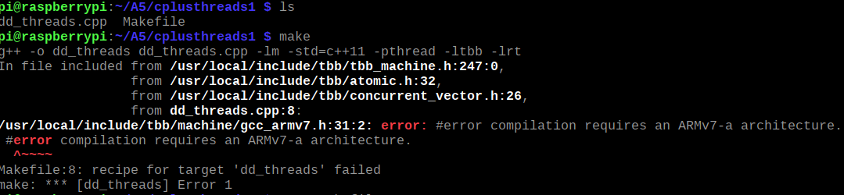

Applying flags.

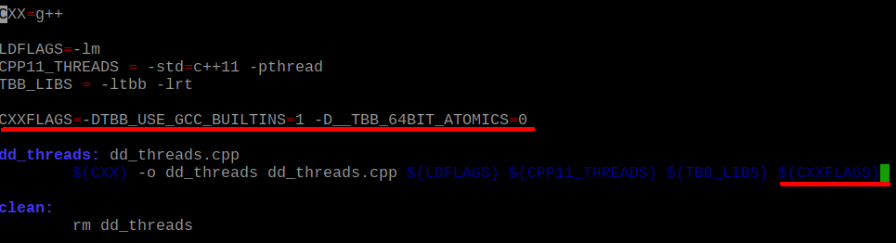

Fix after applying flags.

/Users/Angelica/Desktop/make-therads.png

Time Runs:

|  |  |
| --- | --- |
| Implementation | Times |
| dd_serial | 137.7 |
| dd_omp 1 | 137.68 |
| dd_threads 1 | 131.81 |

dd_serial run-time.

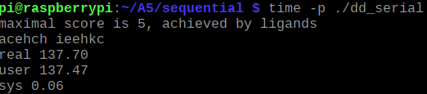

dd_omp 1 run-time.

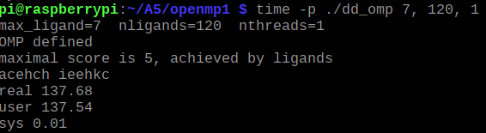

dd_threads 1 run-time.

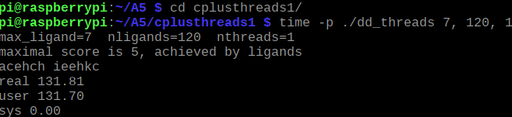

|  |  |  |  |
| --- | --- | --- | --- |
| Implementation | Time (s) 2 Threads | Time (s) 3 Threads | Time (s) 4 Threads |
| dd_omp | 108.09 | 93.20 | 76.96 |
| dd_threads | 76.19 | 54.16 | 42.07 |

DD-omp run-times with 2, 3, and 4 threads.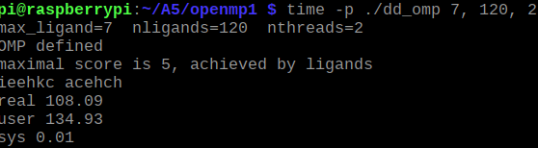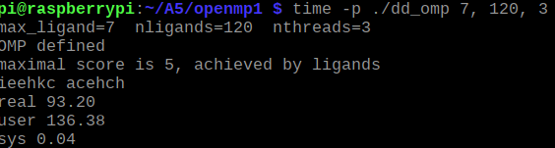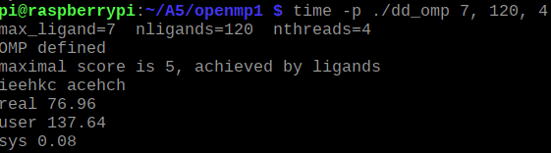

Each time I added threads the real time went down.

dd_threads run-time with 2, 3, and 4 threads.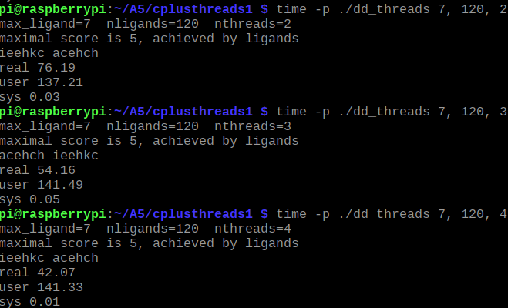

Disscution Questions:

1. Which approach is the fastest?
   1. The C++11 Threads Solution was the fastest.
2. Determine the number of lines in each file (use wc -l). How does the C++11 implementation compare to the OpenMP implementations?
   1. dd_serial: 67.exe, 173.cpp

dd_omp: 179.exe, 193.cpp

dd_threads: 164.exe, 207.cpp

The C++11 implementation has a bit more user code, but the OpenMP implementation has more exacutable code

dd_serial word count.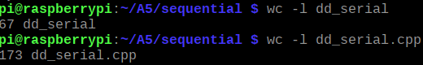

dd_omp word count. 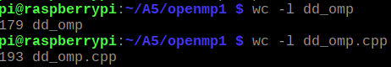

dd_threads word count.

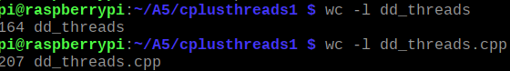

1. Increase the number of threads to 5 threads. What is the run time for each?
   1. dd_threads: 42.79

dd_omp: 74.88

dd_threads with 5 threads.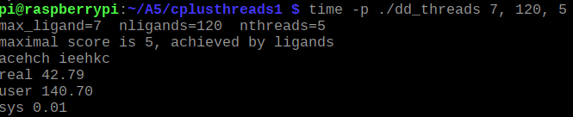

dd_omp with 5 threads.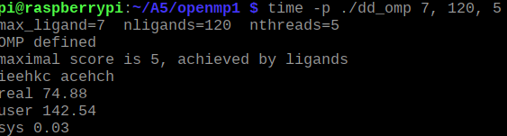

1. Increase the maximum ligand length to 7, and rerun each program. What is the run time for each?
   1. dd_threads: 41.33

dd_omp: 54.87

dd_threads with 7 threads.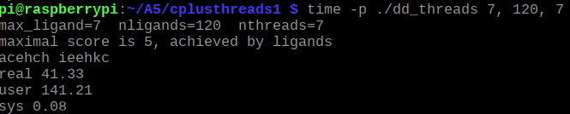

dd_omp with 7 threads.